***DOOR LOCK SYSTEM BASED ON QR CODE***

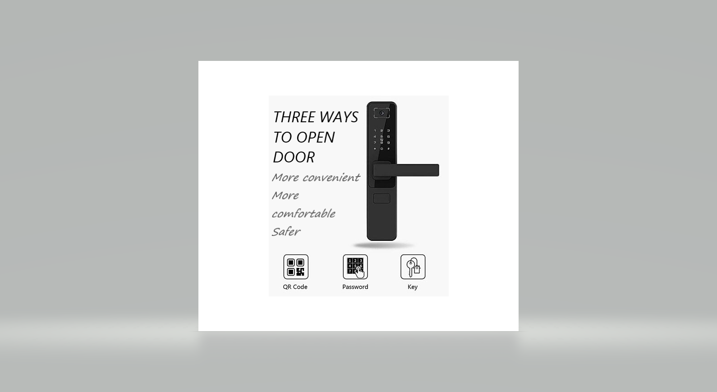

**Abstract:**

Door locks are a common occurrence in our everyday lives. Yet, we still rely on traditional doorknobs that use physical keys that brings with it many problems such as key duplication from photos and lock-picking. There are also costs associated with making keys. This project aims to create a digital door lock system as a better alternative that accepts QR codes.

**Problem statement:**

we know that security is the main priority for us and our door knobs are less secure compared to modern technology. To improve our security, we have to move towards modern technology. **QR CODE DOOR LOCK SYSTEM** is more secure compared to traditional door lock.

**Project Description:**

In this project an advanced security system is presented using QR Identification code, which is specially designed to be used in door locks. The QR system presented here is a new methodology implemented to provide security services to hotel rooms along with better hospitality to guests (or) for homes.

Just we go back to old door lock they can be cracked easily by using some tools. Door locks are a common occurrence in our everyday lives. Yet, we still rely on traditional doorknobs that use physical keys that brings with it many problems such as key duplication from photos and lock-picking. There are also costs

associated with making keys. This project aims to create a digital door lock system as a better alternative that accepts QR codes. when we are using a barcode to open a door lock it will be safer. When user comes to home, he simply holds this QR code against the door computer which authenticates whether the right QR code has been presented by the guest/user and unlocks the door or keeps the door locked accordingly.

**Business Case:**

Door locks are a common occurrence in our everyday lives. Yet, we still rely on traditional door knobs that use physical keys that bring with it many problems such as key duplication from photos and lock-picking. There are also costs associated with making keys. This project aims to create a digital door lock system as a better alternative that accepts QR codes.

QR codes are easily produced and are low cost compared to making a new physical key. Any compromised QR code can be easily deleted or disabled. From day-to-day life we are improving our technology, but still using traditional door knobs does not give security. As we are modern technology, we have to improve our security, so QR CODE DOOR LOCK SYSTEM will replace the traditional door knobs with more security.

**1.EXECUTIVE SUMMARY**

This business case outlines how the QR CODE DOOR LOCK Project will address current business concerns, the benefits of the project, and recommendations and justification of the project. The business case also discusses detailed project goals, performance measures, assumptions, constraints, and alternative options.

**2.STRATEGIC BUSINESS CONTEXT**

**2.1 BUSINESS NEED**

Everyone needs to be secured in this modern technology, and many of using still the traditional door locks, to improve the security we moving towards QR code door lock system, in this way we can easily change and produce new QR to unlock door lock and not easily copied so by using this lock system we are secure.

**2.2 BUSINESS OUTCOME**

By doing this project we can get more security and easily produce and remove the keys (QR code) you don’t want and get recordings like I want time we are using in a day.

**3 DETAILED BUSINESS PROBLEM**

**3.1 PROBEM/ OPPORTUNITY STATEMENT**

All we know that security is the main priority for us and our door knobs are less secure compared to modern technology, to improve our security we have to move towards the modern technology. QR CODE DOOR LOCK SYSTEM is more secure compared to traditional door lock.

**3.2 HIGH LEVEL REQUIREMENTS**

1.OPEN CV4 to run the code belongs to computer vision

2.QR CODES

3.DATA BASE to save the key for door lock

4.CAMERA to scan the QR code.

**3.3 ASSUMPTIONS**

1. We will get the project ready in 4 months

**3.4 STAKEHOLDER ANALYSIS**

|  |  |
| --- | --- |
| **Designation** | **Role in Project** |
| Corporate Head for Sales & Marketing | Executive Sponsor |
| Chief Information Officer or Regional Head of Sales & Marketing | Project Sponsor |
| Finance Head | Cost Approver |
| Business User(s) | Validate the functionalities |

**4. ROLES & RESPONSIBILITIES**

|  |  |
| --- | --- |
| **Project Role** | **Responsibilities** |
| Project Manager | Responsible for planning, organizing, and directing the completion of project for the organization while ensuring this is on time, on budget, and within scope. |
| Technical Lead | Plan, design, develop, and launch efficient business, financial, and operations systems in support of  Core organizational functions and business processes |
| Business Analyst | Helping businesses implement technology  solutions in a cost-effective way by determining the requirements of a project  or program, and communicating them clearly to stakeholders, facilitators and  partners. |
| Developer | Professional who designs, creates, and  customizes software applications to meet the business and functional  requirements |
| Tester | Creating Test Plan and Develop Test Cases |

PROJECT METHODOLOGY AND STAKEHOLDER ANALYISIS

# Executive Summary

We choose the “Agile methodology” as it is a more flexible and efficient way to get products to market. The word ‘agile’ refers to the ability to move quickly and easily. Therefore, an Agile approach enables project teams to adapt faster and easier compared to other project methodologies. The Agile method works in ongoing sprints of project planning and execution, enabling you to continuously adapt and mature your plan, scope, and design throughout the project. Agile projects require an iterative approach, which supports incremental, frequent, and consistent delivery of workable products to your customer or client. This innovative approach ensures your project team can consistently deliver concrete products without being delayed by changes and evolving requirements. Agile has a high level of customer involvement and includes frequent reviews of progress with both the project team and the customer.

# Selection of Methodology

|  |  |  |
| --- | --- | --- |
| S.NO | **Agile methodology** | **Waterfall methodology** |
| 1 | Agile is a continuous iteration of development and testing in the software development process. | Waterfall is a Linear Sequential Life Cycle Model |
| 2 | Agile methodology is known for its flexibility | Waterfall is a structured software development methodology |
| 3 | Agile which follows an incremental approach | The Waterfall is a sequential design process |
| 4 | Agile performs testing concurrently with software development | Waterfall methodology testing comes after the “Build” phase |
| 5 | Agile allows changes in project development requirement | Waterfall has no scope of changing the requirements once the project development starts |

## Roles and Methods:

* **End users:** These are the people who will use your system, often to fulfil the goals of your principals. They typically want systems which are usable and enable them to do their jobs more effectively.
* **Principals:** These are the decision makers who ultimately pay for and then put your system to use. This includes senior business management, and purchasers of the commercial systems.
* **Partners:** These people make the system work in production. This includes operations staff, support staff, trainers, legal experts, installers, application hosting companies, and application developers on external systems which integrate with yours.
* **Insiders:** These are members of the development team and people who provide technical and business services to your team. This includes enterprise architects, database administrators, security experts, network experts, tool smiths, marketing experts, and sales staff.

# Stakeholder Management

## Identification of Stakeholders

|  |  |  |  |
| --- | --- | --- | --- |
| S.NO | **Project stakeholders** | **Project interest** | **ROLE** |
| 1 | H.R | Making important decisions for the company and monitoring various teams | Decision maker |
| 2 | Employees | Development and Testing of the software | Developer |
| 3 | Investors | Providing funds and resources | Financial support |

## Interest and Influence matrix

|  |  |  |  |  |
| --- | --- | --- | --- | --- |
| **Stakeholder Name** | **Activity / Area / Phase** | **Interest** | **Influence** | **Priority (High / Medium/Low)** |
| Regional Head of Sales & Marketing | Advertising | Low | High | Low |
| Customer | To supply product or service | High | Low | High |
| H.R | Decision maker and Collaborator | High | Low | High |
| Employee | Developing and testing | High | Low | Medium |
| Investor | Investment | High | High | Medium |

## Communication Plan for Stakeholders

Good communications not only guarantee teams understand their specific tasks and responsibilities, but they also make sure each team member understands how even the smallest task contributes – and is vital to – a successful outcome. In addition, a clear strategy is vital to identifying and resolving problems before they become significant issues, and for keeping project stakeholders in the project loop.

* A communication objective will be set before every meeting
* Defining and prioritizing our key stakeholders
* Developing communication tactics for each stakeholder group
* Allocating budget and responsibilities
* Walk through of progress to High Interest and High Influence stakeholders
* Providing single page dashboard and communicate via meetings
* Weekly report for High Interest and Low Influence

**Requirements:**

# 1.Executive Summary

This project is QR CODE DOOR LOCK SYSTEM. The main theme of this project is to improve the security using QR code to unlock the door. This project provides security compared to traditional door locks. This project gives such flexibility like we can change door unlock QR in a minute and produce new one.

# 2.Project Scope

|  |  |  |
| --- | --- | --- |
| **S.NO** | **Activities In Scope** | **Activities Out of Scope** |
| 1. | Designing and providing all user requirements. | Opening of door lock within seconds |
| 2. | Developing | Designed to work with sliding latch |
| 3. | Testing | Using valid QR code |

## 2.1.In Scope

The Lock mate is intended as an alternative solution to the current proximity card lock used

## 2.2.Out of Scope

The system assumes that there is only one door to be controlled.

The only valid form of input will be QR codes.

The system is designed to work with a sliding latch lock.

# 3.Epics [Major Functions]

|  |  |
| --- | --- |
| **EPIC** | **EPIC DESCRIPTION** |
| E1 | Creating a code to decode QR code |
| E2 | Storing QR codes |
| E3 | Linking the database with the code to decode the QR code |

## 4. Functional Requirements

The functional requirements include unlocking the door with a QR code, recording exit and entries, managing (adding, removing and editing) valid keys.

|  |  |  |  |  |
| --- | --- | --- | --- | --- |
| **Requirement (#)** | **Requirement Specification** | **Department** | **Name of Business User** | **Status** |
| E1FR1 | Unlocking door using QR code | Designing and Creating | User | unknown |
| E1FR2 | As a tester, I should be responsible for creating test plans, developing cases and testing software | Tester | User | unknown |
| E1FR3 | Adding and removing keys (QR codes). | Database Management System | User | unknown |

## 4.1.Non-Functional Requirements:

|  |  |  |  |  |  |
| --- | --- | --- | --- | --- | --- |
| **Requirement**  **(#)** | **Category of**  **NFR** | **Requirement**  **Specification** | **Department** | **Name of**  **Business User** | **Status** |
| NFR1 | Performance | The system must unlock within 5 seconds of scan the QR code. | Designing and Technical | User | Pending |
| NFR2 | Performance | The system should indicate the validity of a QR code with sound effects | Designing and Technical | User | Pending |
| NFR3 | Availability | System will be available even if there is no power using a Secondary power source. | Electrical | Technical Team | Pending |
| NFR4 | Confidentiality | All data should be encrypted. | Database | Database  Specialist | Pending |
| NFR5 | Traceability | System must trace a QR code within 1 meter | Software | Software Team | Pending |
| NFR6 | Extensibility | Service should be available to all police stations | Management | Project Manager | Pending |

## 4.2.Infrastructure Requirements

|  |  |  |  |  |
| --- | --- | --- | --- | --- |
| **Requirement (#)** | **Requirement Specification** | **Department** | **Name of Business User / Project Team Member** | **Status** |
| IR1 | Funds | Financial | User | Pending |
| IR2 | Software requirement | Technical | User | Pending |
| IR3 | Camera | Designing | User | Pending |
| IR4 | Arduino | Technical | Rajat Kumar | Pending |

**4.3.Requirement definition in Agile**

User story is the smallest unit of work in an agile framework. It’s an end goal, not a feature, expressed from the software user’s perspective.

|  |  |  |
| --- | --- | --- |
| **User Story** | **Acceptance Criteria** | **Size of User Story** |
| As a student, I should be able to set a flexible budget and be warning limits to notify me. | Set a budget that can be updated anytime.  Will be able to add one limit warning criteria. | Medium |

**PROJECT MANAGEMENT PLAN AND EFFORT ESTIMATION**

# Executive Summary

Cost estimation is the process that takes the factors into account, and calculates the budget that meets the financial commitment necessary for a successful project. Project cost estimation applies to everything from building a bridge to developing a new project.

The other requirements include infrastructure and resources that are the basic needs for the project development which are the workspace, system requirements (computer and software's), skilled employees.

Project Management Plan

Describe the key issues driving the project. Summarize the results of the project identification stage (e.g., feasibility assessment and business case). Summarize the solution selected from the Business Case. Define the objectives of the project and the intended business results. Define quantitative and measurable objectives that can be used as criteria by which key stakeholders will judge the success of the project. Some of this information can be extracted from the project charter.

|  |  |
| --- | --- |
| **Focus Area** | **Details** |
| Integration Management | Governance Framework  Project Team Structure  Roles & Responsibilities of Team  Change Management  (Change Control, Issue Management)  Project Closure |
| Scope Management | Scope Statement  Requirement Management (Gathering, Control, Assumption, Constraint Stakeholder)  Define Deliverable  Requirement Change Control  Activities and Sub-Tasks |
| Schedule Management | Define Milestones  Schedule Control |
| Cost Management | Estimate Effort  Assign Team  Budget Control |
| Quality Management | Quality Assurance: Quality assurance will be managed including governance, roles and responsibilities, tools and techniques and reporting  Quality Control: Specify the mechanisms to be used to measure and control the quality of the work products |
| Resource Management | Estimate and manage the need  People: People & Skills Required  Finance: Budget Required  Physical: Facilities, IT Infrastructure |
| Stakeholder | Identifying, Analysing, Engaging Stakeholders |
| Communication Management | Determine communication requirements, roles and responsibilities, tools and techniques. [Type of Communication, Schedule, Mechanism Recipient] |
| Risk Management | Identifying, analysing, and prioritizing project risks |
| Procurement Management | Adhering to organization procurement process |

# Estimation

# Effort and Cost Estimation

|  |  |  |  |  |  |  |
| --- | --- | --- | --- | --- | --- | --- |
| **WBS** | **Activity** | **Activity Description** | **Sub-Task** | **Sub-Task Description** | **Effort (in hours)** | **Cost in INR** |
| E1FR1 | E1R1A1 | Designing | E1R1A1T1 | Confirm the user requirements (acceptance criteria) | 3 | 1500 |
| E1R1A1T2 | Code to decode the QR code detected by the camera. | 5 | 5000 |
| E1R1A1T3 | Database connectivity with the code for decoding the QR code. | 3 | 3000 |
| E2FR2 | E2R2A2 | Testing | E2R2A2T1 | Bug detection | 5 | 2000 |

|  |  |
| --- | --- |
| **Effort (hr)** | **Cost (INR)** |
| 16 | 11500 |

# Infrastructure/Resource Cost

|  |  |  |  |
| --- | --- | --- | --- |
| **Infrastructure Requirement** | **Qty** | **Cost per qty** | **Cost per item** |
| Workplace | 1 | 5000 | 5000 |
| Computers | 2 | 200000 | 100000 |
| Internet connection | 1 | 2500 | 2500 |
| Hosting services | 1 | 3000 | 3000 |
| Stationery | 100 | 5000 | 50-100 |

# Maintenance and Support Cost

|  |  |  |  |  |
| --- | --- | --- | --- | --- |
| **Category** | **Details** | **Qty** | **Cost per qty per annum** | **Cost per item** |
| People | Network, System, Middleware and DB admin Developer, Support Consultant | 3 | 50,000 | 5,000 |
| License | Operating System  Database  Middleware  IDE | 10 | 30,000 | 6,000 |
| Infrastructures | Server, Storage and Network | 20 | 20,000 | 4,000 |

# Project Formation

|  |  |
| --- | --- |
| **Role** | **Responsibilities** |
| Key Business User (Product Owner) | Provide clear business and user requirements |
| Project Manager | Manage the project |
| Business Analyst | Discuss and Document Requirements |
| Technical Lead | Design the end-to-end architecture |
| UX Designer | Design the user experience |
| Frontend Developer | Develop user interface |
| Backend Developer | Design, Develop and Unit Test Services/API/DB |
| Cloud Architect | Design the cost effective, highly available and scalable architecture |
| Cloud Operations | Provision required Services |
| Tester | Define Test Cases and Perform Testing |

**WBS AND RISK MANAGEMENT PLAN:**

# Executive Summary

Detailed summary on Milestone and Schedule of each step:

For Successful delivery and its effectiveness, we have following major steps

**A.**Creating a blue print of a project.

**B.**To design the project according to client requirements and views.

**C.**Start a project on or before Dated: 05/03/2021

**D.**To test the project. Dated: 05/04/2021

**E.**Final stage delivery. Dated: 25/05/2021

**Risk Management:**

Risk Management is the system of identifying, addressing and eliminating the problems before they can damage the project.

A software project can be concerned with a large variety of risks. In order to systematically identify the significant risks which might affect a software project, it is essential to classify risks into different classes. The project manager can then check which risks from each class are relevant to the project.

*There are three main classifications of risks which can affect a software project:*

*Project risks

*Technical risks

*Business risks

# WBS With Project Schedule

|  |  |  |  |  |  |  |  |
| --- | --- | --- | --- | --- | --- | --- | --- |
| Module (#) | Activity (#) | Assignee(s) | Planned Start Date | Planned End Date | Actual Start Date | Actual End Date | Status |
| Discussion on project | Understanding requirement, objective and scope | Vishnu  Ch. Chaitanya  Ch. V. m SaiPraneeth | 25/01/2021 | 5/02/2021 | 1/2/2021 | 10/2/2021 | Done |
| Predevelopment of project | Determining model | Y. VISHNU  Ch. Chaitanya  CH.V.M.SAI Praneeth | 6/2/2021 | 20/2/2021 | 8/2/2021 | 22/2/2021 | Done |
| Project design | Coding | Vishnu  Chaitanya | 20/2/2021 | 5/4/2021 | 28/2/2021 | 13/4/2021 | Ongoing |
| Testing | Bug detection | Vishnu  Praneeth | 5/4/2021 | 25/4/2021 | 13/4/2021 | 30/4/2021 | Yet to done |
| Client Acceptance | Submission and review | Chaitanya  Praneeth | 26/4/2021 | ------- | 5/5/2021 | ------ | Not yet started |

# Risk Identification

Risks are as following:

1. Damage of cam
2. Failure of working sound system
3. Door not open within 5 seconds.

## List (Describe) Register

|  |  |  |
| --- | --- | --- |
| **Risk ID (#)** | **Risk Description** | **Impact Description** |
| R01 | If the cam does not work while showing QR code | The door remains closed even if the user shows the correct QR code. |
| R02 | If the sound system does not work | The user understands the door has not opened. |
| R03 | Not opening the door within 5 seconds. | User thinks not to use the digital door locks. |
| R04 | Hacking of door lock system | Has a high impact as anyone can use. |

## Managing Risk

|  |  |  |  |
| --- | --- | --- | --- |
| **Risk ID (#)** | **Status [Open / Closed]** | **Risk Appetite [ Accept/ Mitigate/ Transfer/Avoid]** | **Action** |
| R01 | Open | Transfer | Using numerical lock |
| R02 | Open | Avoid | Replaced by using LED |
| R03 | Closed | Mitigate | Making the code more efficient |
| R04 | Open | Avoid | Data encryption |

ARCHITECTURE AND DESIGN OF THE SYSTEM

**Software Used**

**Star UML,** Rational Rose, Etc…

**Class Diagram:**

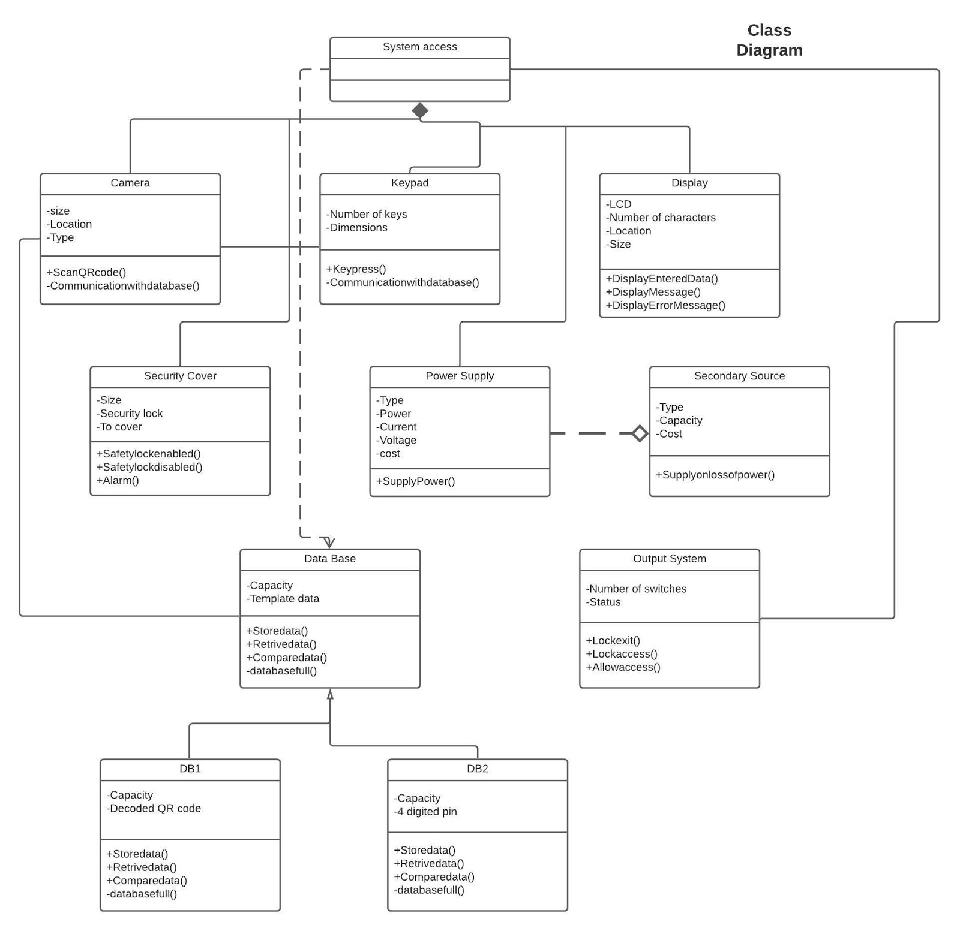

Description:

In software engineering, a class diagram in the [**Unified Modeling Language (UML)**](https://en.wikipedia.org/wiki/Unified_Modeling_Language) is **a type of static structure diagram** that describes the structure of a system by showing the system's classes, their attributes, operations (or methods), and the relationships among objects.

In a door lock system using QR code, we have classes such as camera, keypad, power supply, security, database, display, secondary source and an output system. Each class has a particular attribute in order to perform the specific operations.

**Architecture Diagram:**

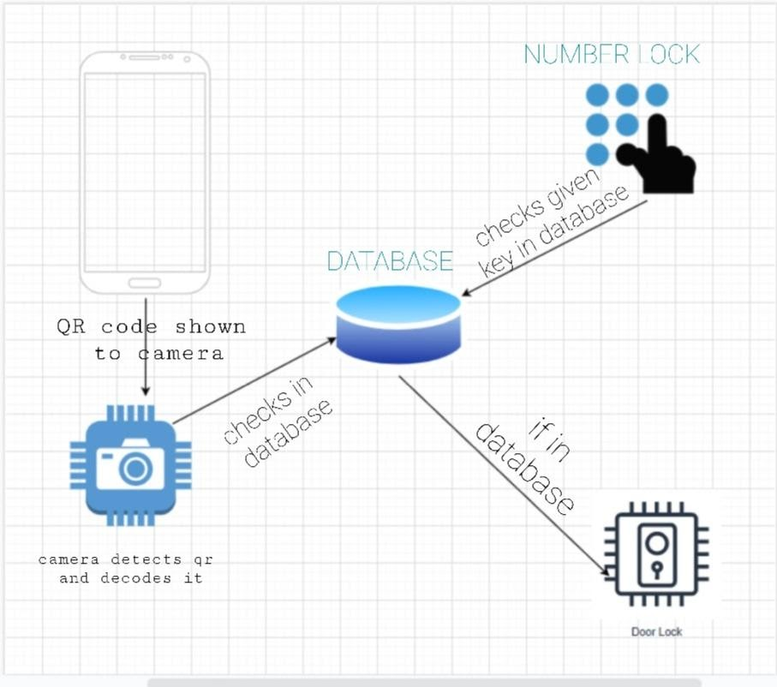

Description:

An **architectural diagram** is a **diagram** of a system that is used to abstract the overall outline of the software system and the relationships, constraints, and boundaries between components. It is an important tool as it provides an overall view of the physical deployment of the software system and its evolution roadmap.

For, door lock system the major components are:

1. A mobile with QR code to scan.
2. A camera to scan the QR code.
3. A keypad to enter the 4-digit pin.
4. A database to access all the above components.

Process: Firstly, QR code is scanned with mobile using the Camera in the door. The scanned QR code will move to the database to get decoded. So, the door unlocks. As an alternative if the camera ruptures after years, a Keypad is also used. Users can unlock the door using a 4-digit pin. Even this moves to the database to decode and finally the door unlocks.

**ER Diagram:**

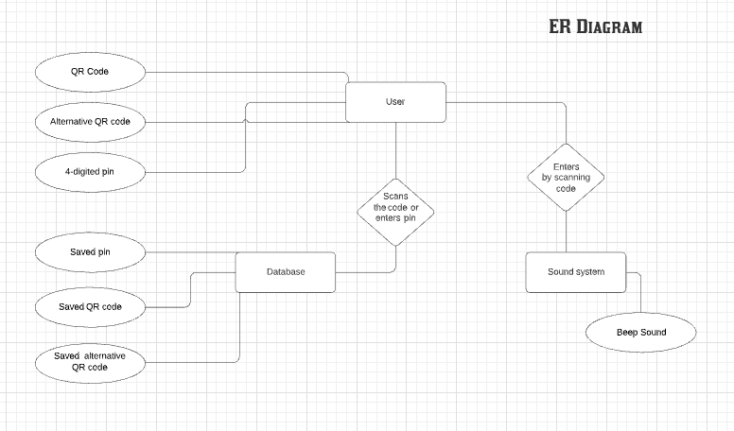

Description:

An Entity Relationship (ER) Diagram is a type of flowchart that illustrates how “entities” such as people, objects or concepts relate to each other within a system. ER Diagrams are most often used to design or debug relational databases in the fields of software engineering, business information systems, education and research. Also known as ERDs or ER Models, they use a defined set of symbols such as rectangles, diamonds, ovals and connecting lines to depict the interconnectedness of entities, relationships and their attributes.

Door lock system using QR code has an entity of QR code, alternative QR code and a 4-digit pin functioned by the user. When the user scans the QR code it moves to the database. The entities in the database are saved QR code, saved alternative QR code and a saved 4-digit pin. As soon as it gets decoded, an entity beep sound is produced from the sound system when the door is open or closed.

**DFD Diagram level 0:**

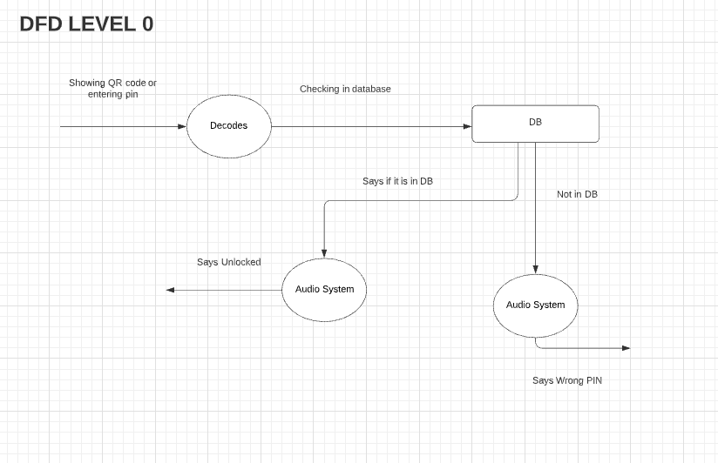

Description:

**DFD Level 0** is also called a **Context Diagram**. It's a basic overview of the whole system or process being analysed or modelled. It's designed to be an at-a-glance view, showing the system as a single high-**level** process, with its relationship to external entities.

It has three major entities are of decoding, DB and audio system. When the user shows QR code or enters the pin it gets decoded and also checks in the database (DB) or not. If it is in DB, then it unlocks with sound. If not, the audio system doesn’t produce sound saying that entered pin or code is wrong**.**

**DFD diagram level 1:**

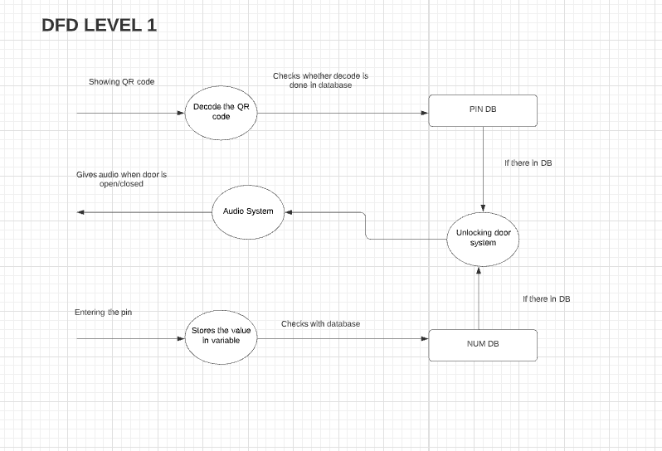

Description:

A DFD (Data flow diagram) of level-1 notates each of the main sub-processes that together form the complete system**.**It is the “exploded view” of the context diagram (DFD Level-0).

By showing the QR code it gets decoded and checks whether it is in database or not. If it is in DB door unlocks with beep sound. Alternatively, by entering the 4-digited pin it gets stores in a variable then checks whether in database or not. Similarly, door unlocks with beep sound if it is in database.

**Use case diagram:**

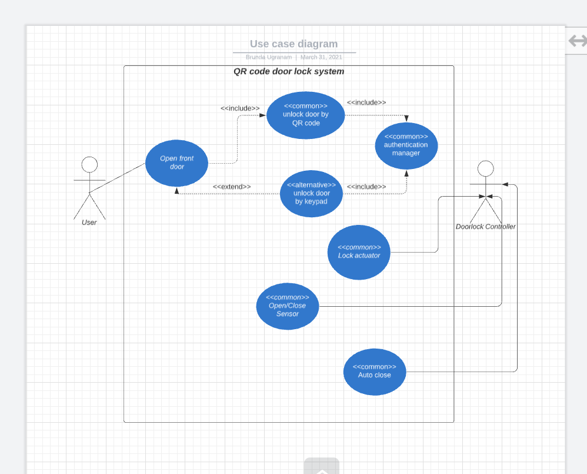

Description:

A **use case diagram** at its simplest is a representation of a user's interaction with the system that shows the relationship between the user and the different **use cases** in which the user is involved.

The user unlocks door by entering pin or by showing QR codes which links up with the authentication manager. A door lock controller has the access to open or close door by sensor, he acts as a lock actuator.

Sequence Diagram:

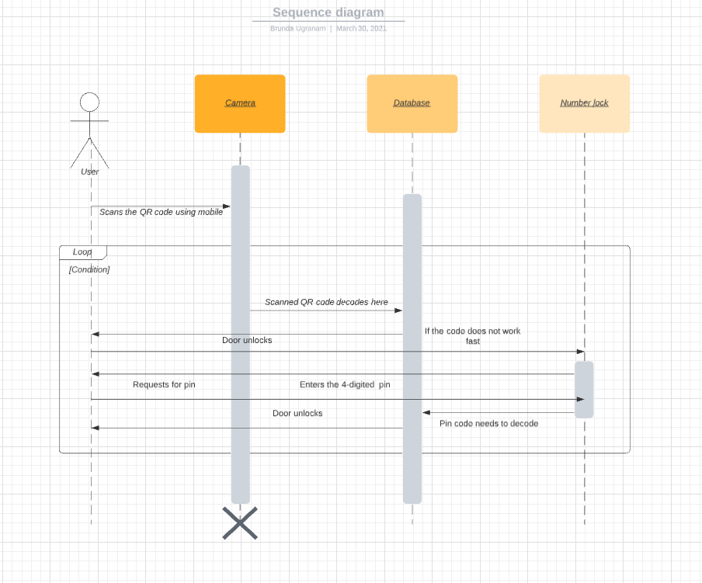

Description:

A **sequence diagram** shows object interactions arranged in time sequence. It depicts the objects involved in the scenario and the sequence of messages exchanged between the objects needed to carry out the functionality of the scenario. Sequence diagrams are typically associated with use case realizations in the [Logical View](https://en.wikipedia.org/wiki/4%2B1_architectural_view_model) of the system under development. Sequence diagrams are sometimes called **event diagrams** or **event scenarios**.

The major objects involved here are camera, database and a number lock. User scans the QR code from mobile through the camera. In database, the code gets decoded and door unlocks. As an alternative, it has a number lock it requests for pin. User enters the 4-digited pin then pin gets decoded in database. Finally, door unlocks.

**Collaboration Diagram:**

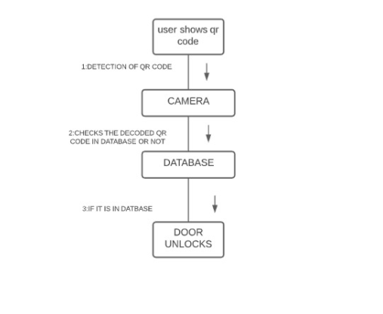

Description:

Collaboration diagrams (**known as Communication Diagram in UML 2.x**) are used to show how objects interact to perform the behaviour of a particular use case, or a part of a use case. Along with sequence diagrams, collaboration is used by designers to define and clarify the roles of the objects that perform a particular flow of events of a use case. They are the primary source of information used to determining class responsibilities and interfaces.

The detection of QR code is done by showing the QR code through camera. Then checks whether the decoded code is in database or not. If it is in database then the door unlocks.

**State diagram:**

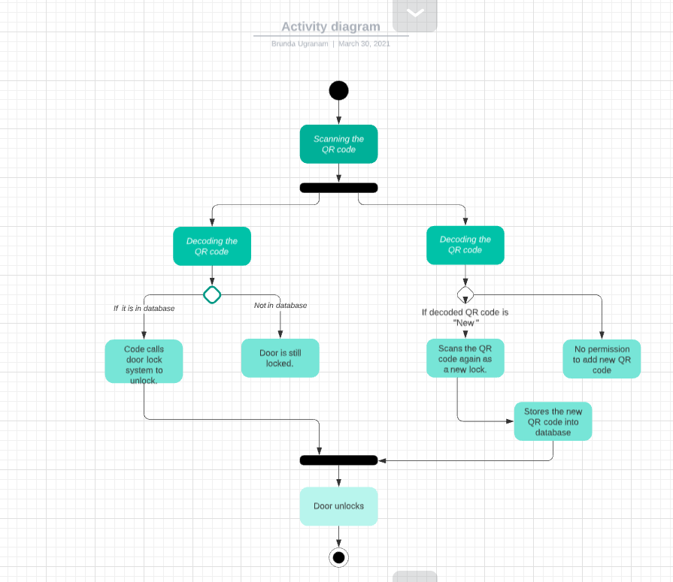

Description:

It describes different states of a component in a system. The states are specific to a component/object of a system.

The process starts by scanning the QR code it has two flows with same object i.e, decoding QR code. In the first flow, checks whether the code is in database. If it is in database, door unlocks or else the door is still locked. In the second flow, if the decoded QR code is new then it knew that the scanned QR code as a new lock. If not, there will be no permission to add new QR code. The scanned new QR code stores in database then door unlocks.

**Deployment diagram:**

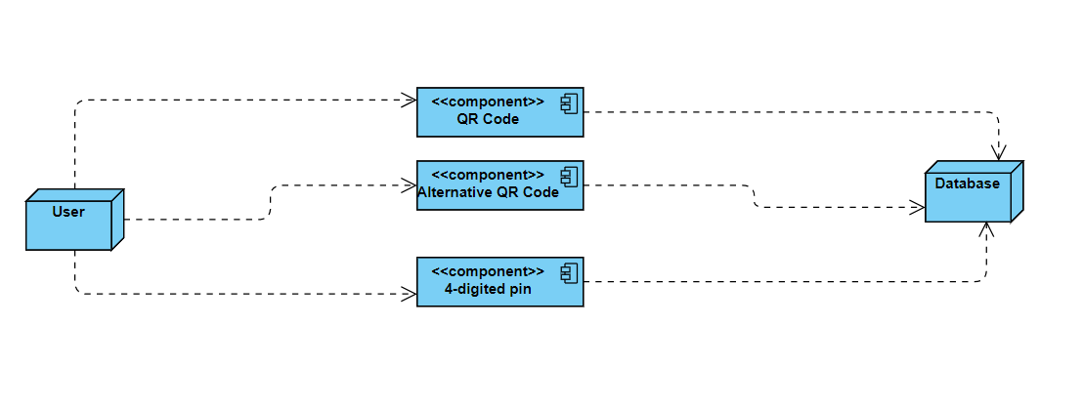

Description:

Deployment diagrams are used to visualize the topology of the physical components of a system, where the software components are deployed.

Deployment diagrams are used to describe the static deployment view of a system. Deployment diagrams consist of nodes and their relationships. The user has the QR code, alternative QR code and a 4-digited pin. These are again linked to database to get decoded to unlock the door.

**Sample Frontend design:**

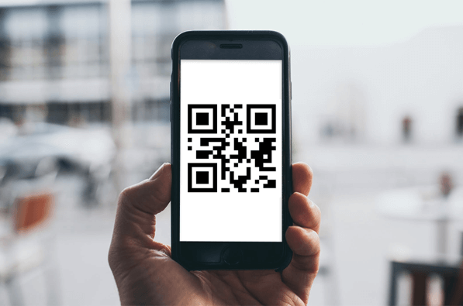

Module Description And Implementation:

*Module 1: -*

The module1 fully covers decoding of QR code shown by user.

Software Used: Python

Modules included: OPENCV2, NUMPY, PYZBAR

**Code of Module 1:**

#Including or importing all modules

import cv2

import numpy as np

import pyzbar.pyzbar as pyzbar

#here we used VideoCapture to start video capturing

cap = cv2.VideoCapture(0)

#setting frame size

cap.set(3,640)

cap.set(4,480)

#setting the font on screen frame

font = cv2.FONT_HERSHEY_PLAIN

#using string variable to store the decoded qr code

str=""

#running an infinite loop to read the qr code

while True:

success,frame = cap.read()

#here the qr decode using decode() function and stored all data in decodedobjects

decodedObjects = pyzbar.decode(frame)

#We are taking variable and using that variable we are printing decoded one

for obj in decodedObjects:

str=obj.data.decode('utf-8')

print("DECODED QR CODE IS",str)

cv2.putText(frame, str(obj.data), (50, 50), font, 2,(255, 0, 0), 3)

cv2.imshow("Frame", frame)

#wait key is used to stop running of the code

key = cv2.waitKey(0)

if key == 27:

Break

**OUTPUT:**

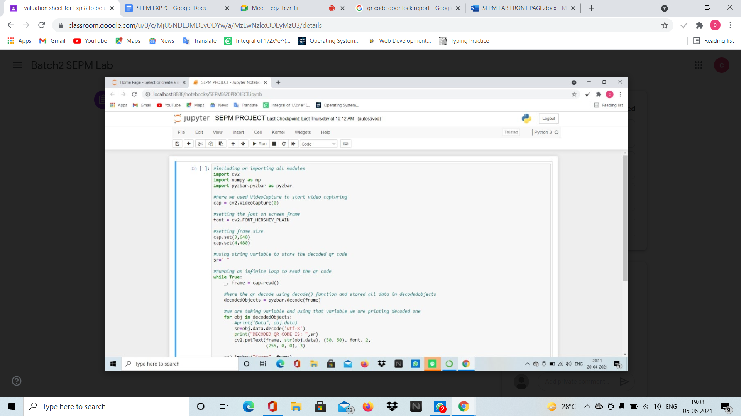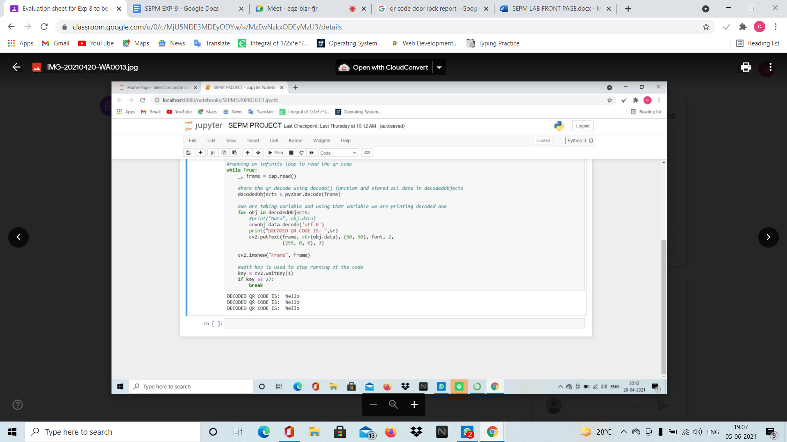

*Module 2: -*

*This module 2 is about unlocking the door using number lock alternate for QR lock. When user enters correct number lock door unlocks by searching entered lock in database.*

**CODE:**

import sqlite3

def func(num):

conn=sqlite3.connect('owner.db')

c=conn.cursor()

c.execute("""CREATE TABLE IF NOT EXISTS ju ( pass varchar(20))""")

c.execute("SELECT * FROM ju ")

if len(c.fetchall())==0:

c.execute("INSERT INTO ju VALUES('12345')")

c.execute("INSERT INTO ju VALUES('112233')")

c.execute("INSERT INTO ju VALUES('998877')")

c.execute("SELECT * FROM ju where pass=?",(num,))

le=len(c.fetchall())

conn.commit()

conn.close()

return le

while 1<2:

num=input("Enter number lock: ")

if func(num)>=1:

print("DOOR UNLOCKED :)")

break

else:

print("*****TRY AGAIN*****")

**OUTPUT:**

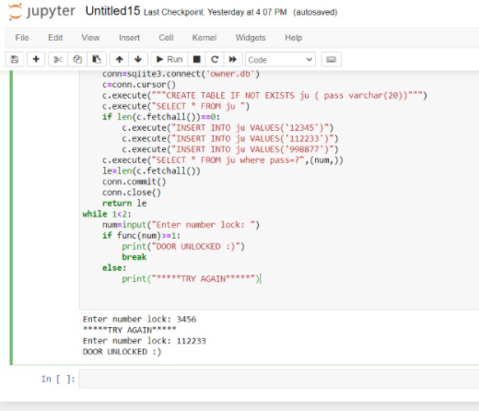

*Module 3: -*

This module 3 is about adding a new QR code as lock and unlocking the door. And in this module, there will be a separate QR code when we show that QR it will accept the new QR into database.

**CODE:**

#including or importing all modules

import cv2

import numpy as np

import pyzbar.pyzbar as pyzbar

import sqlite3

#THIS FUNCTION USED TO DECODE QR CODE

def func():

#here we used VideoCapture to start video capturing

cap = cv2.VideoCapture(0)

#setting the font on screen frame

font = cv2.FONT_HERSHEY_PLAIN

#setting frame size

cap.set(3,640)

cap.set(4,480)

#using string variable to store the decoded qr code

sr=""

decodedObjects=[]

#running an infinite loop to read the qr code

while len(decodedObjects)==0:

_, frame = cap.read()

#here the qr decode using decode() function and stored all data in decodedobjects

decodedObjects = pyzbar.decode(frame)

#We are taking variable and using that variable we are printing decoded one

for obj in decodedObjects:

#print("Data", obj.data)

sr=obj.data.decode('utf-8')

#print("DECODED QR CODE IS: ",sr)

cv2.putText(frame, str(obj.data), (50, 50), font, 2, (255, 0, 0), 3)

cv2.imshow("Frame", frame)

return sr

#THIS FUNCTION USED TO CONNECT WITH DATABASE AND SEARCHING IN DATABASE

def func2():

conn=sqlite3.connect('owner.db')

c=conn.cursor()

c.execute("""CREATE TABLE IF NOT EXISTS qcode ( pass varchar(40))""")

c.execute("SELECT * FROM qcode ")

if len(c.fetchall())==0:

c.execute("INSERT INTO qcode VALUES('qwerty123')")

c.execute("INSERT INTO qcode VALUES('poiu456')")

c.execute("INSERT INTO qcode VALUES('asdfgh789')")

c.execute("INSERT INTO qcode VALUES('hello')")

re=func()

if re=='++NEW++':

print("SHOW NEW QR CODE!!!!")

re=func()

c.execute("INSERT INTO qcode VALUES(?)",(re,))

print("ADDED NEW QR CODE :)")

c.execute("SELECT * FROM qcode where pass=?",(re,))

le=len(c.fetchall())

conn.commit()

conn.close()

return le

while 1<2:

if func2()>=1:

print("DOOR UNLOCKED :)")

break

else:

print("*****TRY AGAIN*****")

**OUTPUTS :**

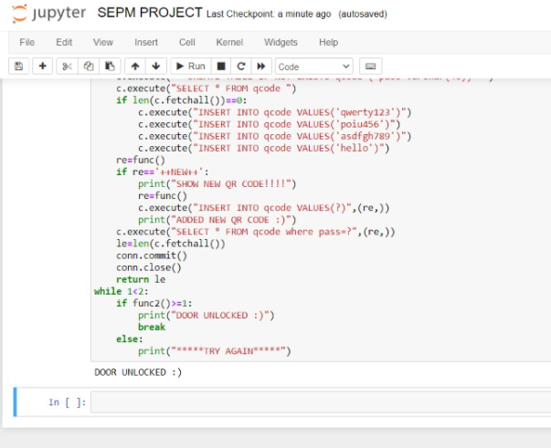

*The above code is the output for the decoded QR code. To add a new QR code the procedure is as follows.*



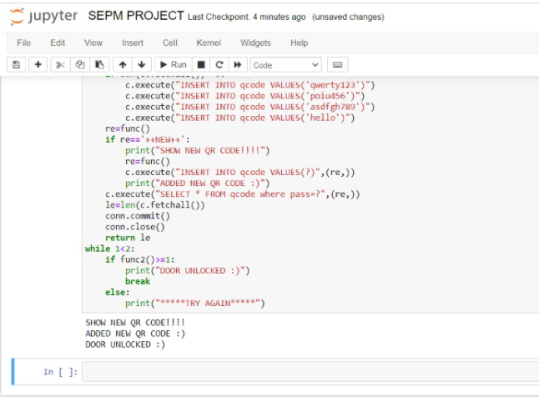

*Master Test Plan, Test Case Design AND Manual Testing With Report:*

# Executive Summary

The testing process is done to find defects which may get created by the programmer while developing the software and to make sure that the end result meets the business and user requirements.

To ensure that it satisfies the BRS that is Business Requirement Specification and SRS that is System Requirement Specifications and also to gain the confidence of the customers by providing them a quality product.

# Test Plan

To prepare a master test plan and conduct manual test using test cases then prepare test report for the project

Scope of Testing

**Functional:** All the Functional requirements are covered

**Non-Functional:** All the Non-Functional requirements are covered

# Types of Testing, Methodology, Tools

|  |  |  |
| --- | --- | --- |
| Category | Methodology | Tools Required |
| Functional Requirements | Manual | Word Template |

# Test Deliverables

Test Case

# Functional Test Cases

|  |  |  |  |  |  |  |  |
| --- | --- | --- | --- | --- | --- | --- | --- |
| **Test ID (#)** | **Test Scenario** | **Test Case** | **Execution Steps** | **Expected Outcome** | **Actual Outcome** | **Status** | **Remarks** |
|  | Verifying the QR code by showing camera | Accept Valid QR code | 1. Detecting the QR code 2. Decoding the QR code 3. Checking in database | User views the message as door unlocks | User views the message as door unlocks | pass | success |
|  | Verifying the QR code | Check For incorrect QR code | Detecting, decoding and checking QR code | QR code is wrong and message displayed as “Try again” | QR code is wrong and message displayed as “Try again” | pass | success |
|  | Adding a new QR code | Accept the new QR code | If the decoded QR code shown by the user “++NEW++”    It accepts the new QR code    Adding new QR code into database | Message displayed as  1.Show new QR code  2. “ADDED NEW QR CODE :)”  3. Door unlocks | Message displayed as  1.Show new QR code  2. “ADDED NEW QR CODE :)”  3. Door unlocks | pass | success |
|  | Verifying user by number lock | Accepts valid number lock | 1) Enter number lock  2) Checking in database | Message displayed as door unlocks | Message displayed as door unlocks | pass | success |

# Non-Functional Test Cases

|  |  |  |  |  |
| --- | --- | --- | --- | --- |
| **Test ID (#)** | **Test Scenario** | **Test Case** | **Status** | **Remarks** |
|  | Performance testing | Detecting and decoding QR code should not exceed more than 5 seconds | Pass | Completed |
|  | Volume testing | Analysing the system performance by increasing the volume of data in database | Pass | Completed |
|  | Usability testing | To identify any usability problems, collect qualitative and quantitative data and determine the participant's satisfaction with the product. | Pass | Completed |
|  | Reliability testing | To check whether the software can perform a failure-free operation for a specified time period in a particular environment. | Pass | Completed |

# Defect Log

|  |  |  |  |
| --- | --- | --- | --- |
| **Requirement #** | **Defect ID #** | **Defect Description** | **Status** |
| M1R1 | RA1 | If the person shows the QR code it contains” ++NEW++” and after that the person does not shows QR code then door does not unlock and system runs until it showing a new QR code | in completed |

# Report

|  |  |  |
| --- | --- | --- |
| **Category** | **Progress Against Plan** | **Status** |
| Functional Testing | Green | Completed |
| Non-Functional Testing | Green | Completed |

|  |  |  |
| --- | --- | --- |
| **Functional** | **Test Case Coverage (%)** | **Status** |
| M1R1 | 50% | Completed |
| M1R2 | 50% | Completed |
| M1R3 | 50% | Completed |

**Conclusion**

The main goal of this project was to achieve several objectives. The first objective was to investigate and analyse the requirements of a quick to use, QR code-based door lock. The Lock system is able to validate a QR code in less than 10 seconds which passes for a quick to use QR code door lock.